**Query for Problem:**

|  |
| --- |
| INSERT INTO FACILITY (FACNO,FACNAME) VALUES (‘F104’,’Swimming Pool’); |

**Snapshot for the Problem:**

1. Before Inserting

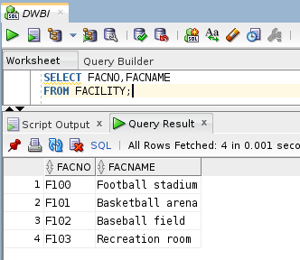

1. Executing Insert Statement

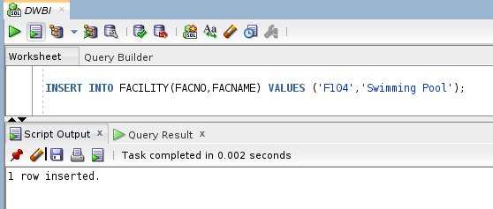

1. After inserting

